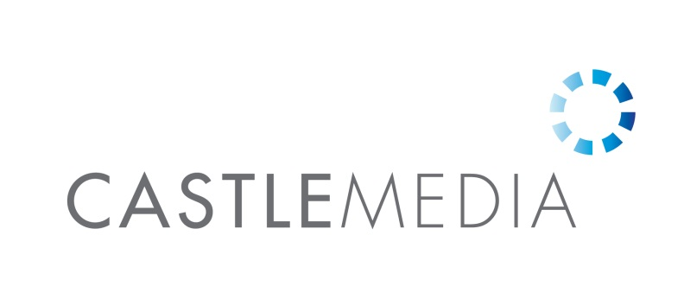
Account Executive, Build It Live
Build It is the oldest and fastest growing self-build magazine in the UK. It is targeted at consumers who are seeking to create their dream home either via a new build or a major renovation. The dynamics of the market are such that although it is a consumer brand, the readers have spending power more commonly seen in B2B media.
Over the last 10 years Build It has undergone a major brand transformation, with a redesigned magazine, new website, plus the launch of industry awards and 2 live exhibitions. Build it is also the only magazine to have self-built its own home which is open to the public as Build It’s Self Build Education House. All these brand elements reflect that Build It has far more focus on the core information needs of its audience than its competitors do, making it uniquely valuable.
Build It is looking for an energetic and highly motivated account executive to join its 7-person sales team. The primary focus of the role will be selling exhibition stands at Build It Live exhibitions to existing and new customers.
As the candidate’s experience grows they will also be able to sell packages across the Build It portfolio of magazine, digital and other events.
Sales experience is not essential but would be an advantage as would experience of live events.
The role is based full-time in Castle Media’s Hammersmith office and reports into Nick Gillam who is the Advertising Director and is also Hammersmith based. However much of the day-to-day management will come from the Business Development Director Sarah Nesbitt-Hawes who leads the exhibition sales remotely.
Responsibilities of role:
- Managing an existing client base who already exhibit at Build It Live.
- Developing new business from targeted sectors primarily via telephone but also via email and face to face at competitor’s events.
- Taking a consultative sales approach to identify the most effective way for companies to exhibit at Build It Live to help them achieve their objectives. This could include the best type of stand to take, effective messaging and added value opportunities including speak slots, Showguide advertising and sponsorship.
- Helping to manage their exhibiting experience whilst at the show and rebooking them into the next show.
- Working with the rest of the sales and editorial teams to enhance the Build It brand.
- Client management at the Build It Live exhibitions and Build It Awards event

Build It’s main website is www.self-build.co.uk
Build It Live’s website is www.builditlive.co.uk
Castle Media’s website is www.castlemedia.co.uk

